The Father of Medical Insurance << Patrick Marie Herbet’s success because of love>>
______________________________________________________________________
Patrick Marie Herbet is the Chairman of Abacare Group, a medical insurance broker, and he is (affectionately) known as “The Father of Medical Insurance" in the insurance industry. He is praised as a great philanthropist. He arrived in Hong Kong some 30 years ago from France, alone, to further his career, enhance his social status and build a happy family life. When we first arrived at Patrick's office, we saw the walls covered with (cherished) photos of his family and friends, as well as a fine and beautiful Chinese calligraphy: he really is a unique individual. Unlike other businessmen from overseas, Patrick is fond of Chinese culture. He is also a Buddhist. If you did not know him, you would never imagine that such an office belongs to a native Frenchman. As a successful person, not only is he humble: when we first met, he shook my hand affectionately and put a heart shaped sticker my arm. It put me at great ease and we interacted like old friends.

Hong Kong Commercial Daily, Reporter Echo, Photographer Choi Kai Man. Part of the pictures are provided by the respondent
Patrick came to Hong Kong in 1982 when he was a young man who had just graduated from university. He is now a leader in the insurance industry. When we asked him the secret to his success, he thought for a few seconds and replied with a smile: "Love the people around you and make them happy". Happiness is very important. When we remain happy with everything we do, we will feel happy the entire day. He thinks that this state of mind can make people around him happy, and it shows how protective he is towards them.

Advices by Tibetan Expert
"I have four goals in my life: the first is to make my family happy; and the second is to make myself happy; and the third is to use my expertise to serve others; and the last is to do good deeds to benefit others. My goals in life are inseparable from "Love": based on this enthusiasm, I joined the insurance industry in order to "protect others from risk", built a group of partners and customers through mutual trust, created the Rotary Club, Karuna Asia and other charitable organizations. I am already on the road to success." When the reporter learnt of Patrick’s secret to success, she could not help but ask him if he has had this point of view on life since childhood. Patrick answered “No” immediately. He has this point of view all because of his Buddhist teacher’s remarks.

Patrick began to encounter the wonder of life after coming to Asia years ago to start his career. Whilst travelling in Tibet he met two local famous "Rinpoche", Lama and Zopa. Patrick asked them, "What should I cherish in life and what should be goals that will lead to true success?" Lama and Zopa answered, "Be involved in the salvation of others, and do good deeds to all people." "Salvation" in Buddhism means set free all life, both animal and human, in order to deliver it from misery. Patrick was sentimental at that moment. He thinks that we cannot bring anything at the end of life; rather than asking, "How to get it", it would be better ask "how to give". The true thinking is to love people, not to harm people. He began with this goal in order to become the person described by the "Rinpoche".

Appreciate the business opportunities in Hong Kong
When Patrick was asked why he chose Hong Kong to start his business, he praised the legal system, low taxes and free business environment, all of which are a paradise for the businessman. "It is difficult to start a business in France. It is almost monopolized by large companies. There are more opportunities abroad. I was worried in case I could not adapt to living abroad. I chose Hong Kong because it is cosmopolitan. Unlike other Asian countries, such as Japan, Korea or Thailand, where I have a feeling of xenophobia due to the language barrier, people in Hong Kong have a high standard of English and they are not afraid of foreigners”.
Patrick shared his experience of setting up his first company. "I like wines and, thereforeI spent HK$600 to set up a wine trading company in Hong Kong in 1993. It was impossible to do so in France." Unfortunately, wines were not as popular as they are now in Hong Kong: business was not good and he got into such financial difficulty that he had only had HK$30 left in his pocket. He had to work as a bartender in the Lan Kwai Fong area (the street of Lan Kwan Fong did not exist at that time).
Patrick expressed frankly that those days were not easy, but he did not give up and he is even very grateful to the experience because it gave him perseverance and courage. Coupled with his Buddhism nurturing, he can easily handle obstacles when he runs into in his company, Abacare Hong Kong Limited. Abacare Hong Kong Limited was formed during the economic turmoil in 1997. It went through SARS, the financial tsunami, etc. To date, his insurance brokerage business has expanded throughout China and Southeast Asia. Abacare now has over 20,000 customers.
"Life in Hong Kong is stressful. I meditate every day to calm myself and focus on my business. If I had not come to Hong Kong, I would not have become the “me” of today. I love Hong Kong because there are business opportunities as long as we don’t give up” Patrick said with smile.
Everyone needs protection in life
Insurance is for when people encounter financial risk, it gives protection during life. About 15 years ago, Patrick had a 64 -year-old friend who smoked and drank. Patrick thought that his friend needed medical insurance due to his bad lifestyle. Therefore, he tried to persuade his friend every time they met. After his friend had taken out the medical insurance, his wife was very unhappy and she even called Patrick and scolded him. Six months later, his friend unfortunately was diagnosed with cancer. His medical bill was HK$500,000. The insurance company reimbursed a sum to his family and that helped them through that difficult time. "Afterwards, the wife's attitude changed completely and she was thankful to me. She said that fortunately I had persuaded her husband to buy the insurance and that alleviated a lot of the burden on her family." Patrick realized deeply the meaning of his insurance work after his friend’s case. "Every living being needs protection. I feel that my work is like providing a safety net for others in order to give them a sense of security," he added.
Mainland China’s backing is Hong Kong’s Superiority
Patrick said that his business in the future will be to actively develop in the market in China. His domestic helper was treated in a government hospital for 5 days in Hong Kong and the bill was only HK$500. . The health care system in Hong Kong is highly praised. "Hong Kong people have such a good health care system. They don’t have to buy medical insurance. However, mainland China is a new and big underdeveloped territory. I have partners in China. China has a high demand for insurance, particularly for medical insurance. We will train more people in this field."
He added that he does not understand why Hong Kong people think there is no need from China in the Hong Kong economy. "I was looking for business opportunities from France all the way to China. But there was no chance in France. Hong Kong people really don’t know how fortunate they are. The Mainland Chinese travellers’ consumption in Hong Kong drives the economy, and they also broaden their international perspective. This is clearly a win-win situation. I really do not understand why they don’t like the Mainland Chinese people in Hong Kong. To ignore the economic potential of the motherland, China,, is “insane".” Patrick said that he thinks he is a Chinese: “If I have to describe myself, I would compare myself to an egg. It is white outside and yellow inside. I look a “Guai Lo” (a westerner), but I have a Chinese mind.”
Diversified taste of life
Although he has lived in Hong Kong for the past 31 years and has cultivated the Hong Kong spirit of hard work, Patrick has not discarded the importance of the French lifestyle. In addition to liking to travel with his family and doing some charity work, he very much enjoys fine cuisine and wines with his friends. He is a member (a Knight) of the French “La Confrérie des Chevaliers du Tastevin”. It is said that becoming a Knights is not very easy. You must be proposed by members of good standing as well as having a comprehensive understanding of wines. In addition, Patrick attends wine tasting events, including those in one of the 5 most famous vineyards namely Chateau Margaux which was host to President Hu Jintao.

Resume of Patrick Marie Herbet
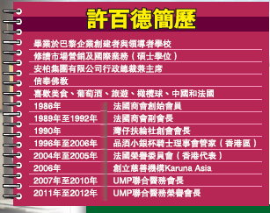
Graduate from the Ecole des Dirigeants et Créateurs d’entreprise – Paris – France
- Major in Marketing and Business Management (Senior Degree)
Chairman and CEO of Abacare Group
A Buddhist
Likes food and good wine, travelling, rugby, China and France
In 1986: Founding Member of the French Chamber of Commerce
1989 to 1992: Vice-president of the French Chamber of Commerce
In 1990: Chartered President of the Rotary Club of Wanchai
1996-2006: Chambellan of the Confrérie des Chevaliers du Tastevin – Sous Commanderie of Hong Kong
2004-2005 General Secretary of the Honorary Committee of the Year of France in China (Hong Kong representative)
2006: Founded Karuna Asia, a charitable organization
2007-2010: President of the UMP Joint Medical Committee
2011-2012: Honorary President of the UMP Joint Medical Committee
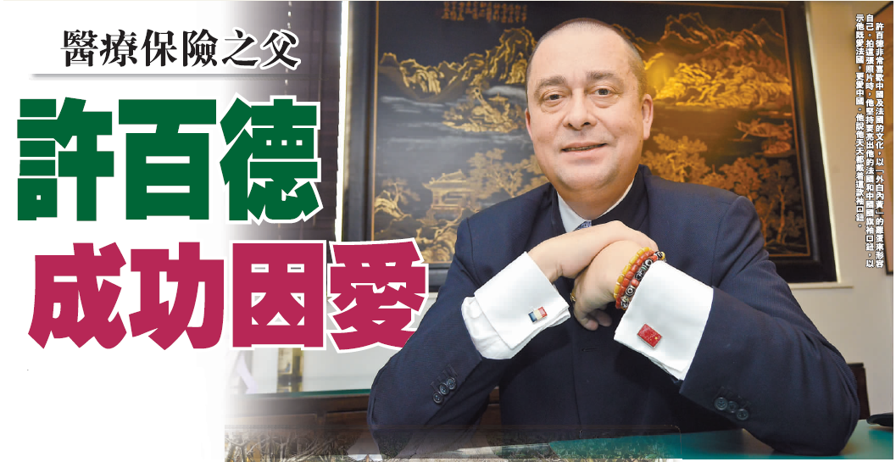

Patrick adores Chinese and French cultures alike and describes himself as an egg (white on the outside, yellow on the inside). When we took this photo, he insisted on showing his French and Chinese flag cufflinks, symbolizing his love of France and his greater love of China. He said that he wears them every single day.
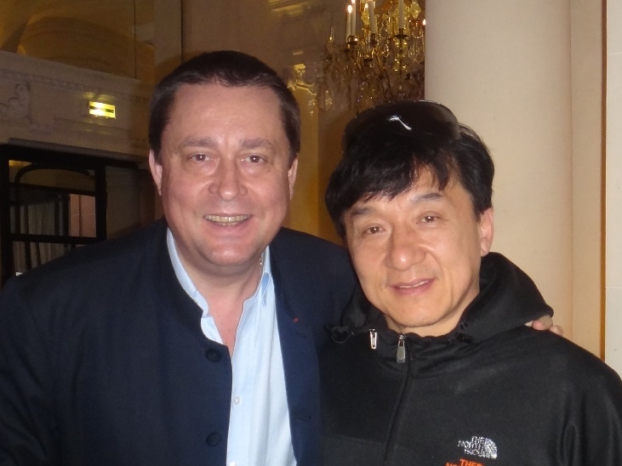
Because he loves others like love himself, Patrick has established an excellent social network Above he is pictured with his good friend, Jackie Chan.
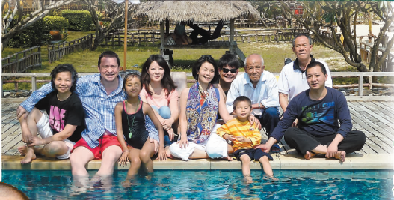
We reporters asked Patrick if we could publish a photo he has of himself with the French President, but he responded that the one of himself with his family is even better. To be a successful person, the one must start with oneself and one’s family. Patrick sees good family relationships as of utmost importance.

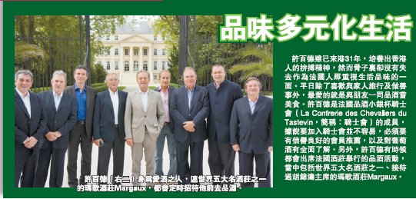
Patrick Marie Herbet (2nd from the right) loves wine and is regularly invited by Chateau Margaux, one of the 5 most famous vineyards in the world, for wine tasting gatherings.

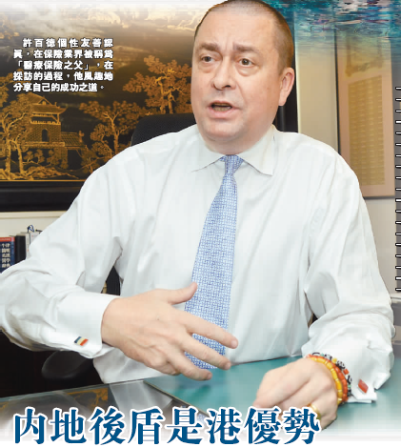
Having a friendly and yet serious personality, Patrick is known as “The Father of medical insurance”. During this interview, he recounted his success with great humour.

